# Exercise 1: Logging Error Messages and Warning Levels

Task: Write a Java application that demonstrates logging error messages and warning levels using SLF4J.

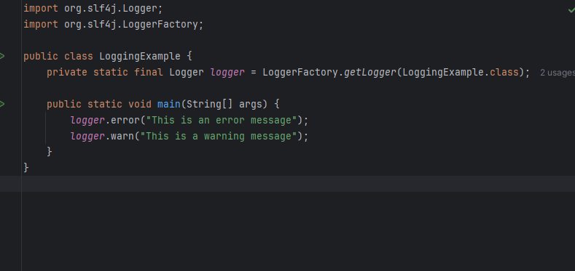

Output:

